


Final REPORT on
MS In Capstone Project
A Comparative Customer Churn Prediction and Retention Strategy Analysis Across SaaS, Telecom, and Credit Card Subscription Businesses
Submitted BY: Sadikshya Shrestha

Table of Contents
Executive Summary 2
Introduction and Problem Statement 3
Literature Review 5
Data Description and Methodology 7
Data Preparation 7
Exploratory Data Analysis 8
Modeling Approach 8
Risk Segmentation 8
Visualization and Reporting 9
Analysis and Result 10
Discussion and Insights 18
Recommendations 19
Limitation and Future Work 22
References 23
Appendices 24
Appendix A : Python Code 24
Appendix B: Visualization 44
Appendix C : Data Dictionary 51

Executive Summary
Churn is considered one of the crucial issues for businesses due to its effect on their recurring revenue, customer lifetime value, and cost of future growth/ In case of customer churn, the organization loses not only the existing revenue from their client but also spends extra money on new clients to compensate for the loss. This problem is particularly relevant to SaaS, Telecommunication Services and Credit Cards, as companies working in these areas depend mainly ongoing client relationships. The research problem defined prior to conducting this study consisted in the fact that previous studies on churn were conducted only for a specific industry and could not help draw comparisons between types of churns in various industries. (Shrestha, Proposal of Capstone Project , 2026)
The current capstone project sought to fill that gap through the development of comparative churn prediction models for three subscription model businesses: SaaS, Telecom and Credit Card. These three industries datasets obtained from Kaggle. Consistent applications of an identical analytical process were employed in all the three industries under consideration to facilitate comparable results. Data acquisition, cleaning, transformation, exploratory analysis, predictive modeling, risk segmentation and development of dashboards formed the main steps in carrying out this project. This project involved the application of three supervised machine learning models: Logistic Regression, Random Forest and Decision Tree. (Shrestha, Proposal of Capstone Project , 2026)
Each dataset had different requirements for data preparation steps, but the methodology was consistent. In credit card dataset, all unnecessary identifiers were removed while churn was represented using binary encoding. “Unknown” categories were handled using mode-based replacement. For telecom, numeric coding and missing value imputation were required for the Totalcharges variable. Furthermore, categorical inconsistencies and duplicate records needed to be handled. The largest number of data transformations occurred in the SaaS dataset since the data existed in several tables. Specifically, the data included accounts, subscription, feature utilization, support request and churn. Each of these needed to be joined together into one data set at the account level. (Shrestha, Data Acquistion & Preparation Report , 2026)
In the case of exploration data analysis, industry specific patterns of churn were observed. In the SaaS environment, low usage intensity, low feature usage and increased use of the support ticket were identified as significant churn indicators. For the Telecom industry, churn showed high association with month-to-month contracts, shorter tenure period, and higher price per month. On the Credit Card industry low transaction volume, low engagement and some patterns among customer categories indicated possible correlation with churn risk. These observations further highlight the critical importance of recognizing a key management implication, which is that despite the existence of churn in all subscription-based services the underlying causes of churn are not the same.
A model cannot be judged based solely on its accuracy. It needs to be analyzed in its entirely using measures such as Precision, Recall, F1 score and ROC AUC- particularly when it comes to predicting customer churn, in which case correctly identifying the customers at risk becomes more important than achieving high accuracy. Random Forest was the best performing algorithm in each industry, consistent with scholarly finding that ensembles are better than simple models. (Delaere, Matthias Bogaert and Lex, 2023)
In the visualization phase, technical issues with Tableau have caused shift towards Microsoft Power BI. However, the new technology did not impact the analysis process but enhanced the capacity for creating interactive dashboards. The generated dashboards were successful presenting churn KPIs, risk segmentation, customer characteristics, model comparison and industry comparison effectively.
From business standpoint, there are three key contributors made by the project. First it proves that churn prediction can be compared in a standardized way while still taking into account the difference in features significance between industries. Second, it demonstrated that predictive analytics can be develop a retention strategy by segmenting customers based on their risk- high, medium and low. Lastly, it helps to apply analysis results to decision making by providing via dashboards and recommendations for managers. SaaS firms will likely benefit from customer success management and product adoption intervention more than general marketing campaigns. For Telecommunication providers, contract designs, billing strategy and tenure-based offers play an important role. Credit Card users need to stimulate card usage, reward loyal clients and monitor early churn signals.
In conclusion, it was established that churn analytics works best when predictive modeling is integrated with business strategies. While the final result does not solely consist in comparing algorithms, it provided managers with a solution to identify high risk customers and recommend retention measures in three distinct industries.

Introduction and Problem Statement
In today’s world of data driven businesses, retaining customers is just as critical as gaining them. Especially for businesses which operate on a subscription model, their survival and success depend on maintaining customer relations and continuing to generate value for them. Customer churn describes the phenomenon of losing customers or terminating a customer business relationship. For SaaS industry this will result in cancellations or decreased use resulting in cancellation. In the Telecommunication industry, this will be defined as changing carrier and leaving one’s contract. In the case of Credit Card industry churn would be indicated through inactivity and closures of accounts. While the processes in each industry are different the challenge faced by all three industries is the same. (Shrestha, Proposal of Capstone Project , 2026)
There is plenty of literature regarding the significance of churn prediction for business. Indeed, academic studies have proved that effective prediction of churns helps companies implement preventive measures as well as manage resources more effectively when handling their customers. In the telecommunication sector, there have been many studies devoted to the potential churn prediction as application of machine learning. The reason for that was that telecommunication companies have a larger customer base, experience serious competition and possess significant behavioral and payment data on customers. (Nurulhuda Mustafa, 2021)
The issue that sparked this capstone research is the concentration of existing studies on a single business sector. Although such an approach provides industry-specific results, it creates challenges when trying to make comparisons between churn determinants in various industries and determining whether any analysis methods can be applied across different sectors. In the accepted proposal, the problem was stated in the following terms: organizations and scientists may not have a way to compare the differences in churn predictors among SaaS, telecommunication, and credit card subscription models. (Shrestha, Proposal of Capstone Project , 2026)
Hence, this project took on the more comparative and strategic approach towards addressing churn predictions in an organizational context by asking how churn models could be developed and analyzed within the three different businesses that were based upon the same concept of subscription-based industries. By framing this project into more strategic decision-making issues rather than a technical one, the importance of churn analysis in the context of business can be better realized. The reason behind this is that the goal of churn analysis is not merely classification.
The first aim of this research was to design and evaluate churn models for customers of SaaS, Telecommunications and Credit Card companies using the same methodology. The second aim was to discover the major trends regarding churn form each of the three industries using exploratory data analysis. The third aim was to derive actionable insights from the outputs of the models. The fourth aim was to generate business relevant visualization of the results.
The research questions posted for the study were as follows:
- What behavioral, financial and account level factors seem to have an association with customer churn in SaaS, Telecommunications and Credit Card firms?
- Are there any differences in churn behavior among the three industries?
- Which of the following supervised learning models performs the best within and across the datasets: Logistic Regression, Decision Tree and Random Forest
- How may the predicted probabilities of churn be used to form risk-based customer segments?
- What recommendations are made by the analysis for the respective industries?
These issues have direct relevance to the project proposal, as well as to the mid-term progress report since they focused on comparative modeling, inter-industry comparison and risk-based customer segmentation as the key aims of the capstone. (Shrestha, Mid Semester Check Point Evaluation Report , 2026)
The practical significance of the project relates to its management-oriented nature. For instance, the manager at Telecom provided would be interested in knowing what the most relevant factors of churn are- contract structure, internet services and tenure; SaaS company manager may find feature usage, onboarding and support experience as more significant, whereas the manager of Credit Card company will be mostly interested in transactional behavior and customer value. Through comparative industry analysis in single context, the study will provide insights into similarities and differences of churn behavior across industries.
Lastly, there is a practical factor related to how the project progressed during its implementation. The initial plan involved using Tableau for visualization purposes. However, technical problems arose during this phase and that made it impossible to continue working with Tableau. Consequently, Power BI was used for dashboard creation. This detail is significant since it is a practical adjustment to the project management process, not the conceptual one. All aspects of the project design were preserved, including data processing techniques, predictive model logic, and business objectives. Only the visualization part was altered to adapt to the situation.
Overall, the problem context, business importance, and research methodology make this capstone project a hybrid between an analytical investigation and a business strategy session. The project is concerned with churn not merely as a classification problem but rather as a retention issue applicable across all industries.

Literature Review
Churn prediction using machine learning algorithms has evolved into one of the most well-established applications of business analytics using ML methods. The relevance of churn predictions is high within the industries where there are repetitive customer relations, transactional histories of considerable size and measurable engagement activities. In reviewing the existing research, the literature suggests that churn predictions models are most useful when they possess both a high degree of predictability and interpretability that would allow managers to understand why a customer might leave. (Arno De Caigny, 2018) (Samira Khodabandehlou, 2017)
Many academic papers have been devoted to machine learning algorithms for predicting customer churn. Logistic Regressions is still extensively used due to its computational simplicity and interpretability. It gives analyst an opportunity to understand the direction and magnitude of impact of each predictor on the outcome of interest. Another reason for using Decision Trees is their capability to provide rules in terms of human language. Most more complicated approaches like Random Forest are usually superior in terms of predictive power since they account for non-linear relations between variables and interactions that occur frequently in practice. (Arno De Caigny, 2018) (Delaere, 2023)
The telecommunication industry sector is among those sectors that have been extensively studies in the context of churn prediction. It provided detailed information on customers and exhibits relatively high levels of churn behavior. Previous literature on telecom churn has revealed that tenure, type of contact, price model, service quality and utilization patterns are some of the most important churn predictors. Moreover, recent studies on telecom churn prediction have emphasized the importance of explaining results since prediction results do not provide any value to decision makers if explanation for these are lacking. (Nurulhuda Mustafa, 2021)
In similar vein, the research on credit cards and banking discusses issue of churn or attrition as being significant to probability. This is because banks make money out of continuous usage of cards and their profitability from the lifetime value of a customer. Therefore, such models could prove very useful in determining the attrition risk of customers. Some of the features which have been used previously for prediction include number of transactions, limits, utilization, demographics and account age. The machine learning models for customer attrition in the domain of credit cards have shown that the problem can be modeled using either interpretable or sophisticated techniques where Random Forest models have performed well. (Dana AL-Najjar, 2022)
There has been much academic research done on SaaS churn in recent years, as more information about product usage and customer support becomes available for digital subscriptions companies. In contrast to telecommunication and banking sectors where churn is potentially more correlated with billing processes and contractual agreements, SaaS churn may have some relations to the process of adoption of software products, their actual usage, and customer service support provided. Engagement-related variables are found to be essential in determining a models’ predictive power, as SaaS churn models become especially valuable when usage, billing and customer service support are considered together. (Muhammed Kotan, 2025)
A crucial concept that has been identified from the existing literature is that there is balance to be struck between model predictivity and explainability. Even though more sophisticated machine learning techniques might result in increased accuracy, they can become harder for business personnel to comprehend. Hence, an approach has been suggested which seeks to combine both the aspects, particularly within the realm of customer retention, where decision making may impact prices, incentives, communications outreach or customer experience management. (Arno De Caigny, 2018)
Segmentation also remains a significant concept. It enhances the usefulness of churn prediction by providing a way to classify probabilities into levels of risk such as low, moderate and high risk for churn. This allows for action through prioritization, offering incentives and interest in order to ensure customer success. Prior research in banks and telecommunication has already demonstrated that this approach based on segmentation is more useful than simply predicting the probability. This study takes the same approach by turning model predictions into segments and presenting results through dashboards. (Sarkaft Saleh, 2023)
In summary, the review of literature has identified four main findings that are pertinent to this capstone project. First, churn prediction is an established and strategically important application of machine learning. Second, the key variables differ based on the sector and type of organization. Third, the use of Random Forest and other ensemble techniques typically yields good predictions; however, interpretable models still have value for communicating the findings to managers. Finally, risk stratification and visualization tools help enhance the utility of the churn analysis.

Data Description and Methodology
In this study, three datasets relating to specific industries: SaaS, Telecommunication and Credit Card services were used. All three datasets used were sourced from Kaggle and chosen based on subscription or repeat customer nature, which made them relevant to for comparing churn in different sectors. In terms of data size, Credit Card dataset has approximately 10,000 customers records, while the Telecom dataset included approximately 7,000 customers records and the SaaS dataset, consisted of five relational tables that had to be combined to conduct modeling.
Specifically, the Credit Card dataset included customer demographics, account data, transaction data, credit data and churn indicator based on attrition. The Telecom dataset consists of customer demographics, customer contract information, internet service attributes, billing information, tenure and customer churn indicator. Lastly, SaaS dataset included accounts, subscription, feature usage, customer tickets and customer churn. As highlighted in Data Acquisition & Preparation Report the datasets mentioned can be considered similar in terms of common variable groups such as demographic, account, behavior, financial and target variables.
One of the important objectives of the methodology used in this project was to ensure consistency of the analytics process wherever possible among all three sectors. Though there were differences in preprocessing stage for the datasets from different sectors, the overall stages of the process were uniform, which included extract-transform-load (ETL), exploratory data analysis (EDA), modeling risk segmentation and dashboard-based communication.

Data Preparation
In credit card data set, the initial phase included loading of the data followed by basic observation of data and decision of any unnecessary columns such as CustomerNumber. Churn was coded in binary format as 1 for attrition case as 0 for customers who are still part of the company. The unknown category in variables like Education and Income was handled through mode replacement because there was ambiguity about this category in the analysis. There was no missing values or duplicates while doing quality check validation phase.
The telecom data set needed more data cleaning. The variable TotalCharges was inappropriately formatted, and thus conversion to a numeric value through coercion was necessary. Missing values generated during this conversion process were replaced with medians, as billing amounts may be skewed. The data set did not have leading trailing spaces on its categorical variables. Moreover, the yes/no format in the variables Churn was transformed to binary 1/0. There were 22 rows that were duplicated in the report.
The dataset for the SaaS business needed the maximum amount of preparation due to its form as several relational databases. The account and subscription database tables were linked together with the feature usage database and the support ticket database. Feature usage was rolled up to the account level for variables such as total number of usage events and total feature interactions. The same was done with the support ticket database for representing the service friction or support dependency. A variable indicating whether an account had churn events was generated, and when there was missing information about support or usage variables, a zero value was used.

Exploratory Data Analysis
EDA was used in order to explore the nature of churn as well as distribution of the different variables, presence of outliers and any preliminary correlation between the predictors and churn. As mentioned above, the specific areas of focus were defined as the distribution of churn, customer involvement, patterns of use and billing, as part of the mid term report. In addition, EDA was used to detect imbalances in classes and find out which variables correlated with churn in each industry.

Modeling Approach
During the predictive modeling process, three machine learning techniques were used: Logistic Regression, Decision Tree and Random Forest. These were chosen for both methodological and practical reasons. Logistic Regression served as baseline model due to its excellent interpretability. Decision Tree allowed creating understandable decision rules that can be explained to the management. Random Forest was powerful ensemble method for better capturing non-linear dependencies within the dataset. This choice was explained and planned ahead of time in proposal.
For the assessment of model performance, binary classification metrics were used: Precision, Recall, F1 Score and ROC AUC. The use of multiple metrics is necessary for a correct evaluation since churn predictions dataset often have imbalanced costs of making errors in predictions. Recall is important when it is essential to detect customers who will terminate the subscription and precision is crucial if it is difficult to retain clients. The literature advises evaluating churn predictions models using different metrics.

Risk Segmentation
Following the model development, probabilities for churn were then converted to risk segments. Consumers were classified as either low, medium or high risks depending on their likelihood of churning. The segmentation made the results more practical for use within a business environment. Rather than just providing predictions in terms of probabilities, the study generated risk-based segments which could be used in retention programs or any other customer success strategy.

Visualization and Reporting
The original plan for visualizing the data using Tableau was detailed in the proposal. However, implementation problems in Tableau slowed down the process during the report writing phase. To maintain the momentum and finish the project on time dashboard development was shifted to Power BI. This decision did not affect the model building process and its outcomes; it concerned the reporting layer only. Hence, in addition to the model itself, the project includes dashboards built using Power BI for cross-sectoral analysis and SaaS, telecom, and credit card sectors separately.
Methodological Justification
There are three reasons why the methodology is suitable for achieving the goal of the project. First, it allows for industry comparisons without making each data set fit into a preconceived, forced format. Second, it helps strike a balance between interpretation and prediction through comparative analyses of models belonging to distinct families. Third, it converts technical output into dashboard-driven decision-making. Academically, from a capstone point of view, all these elements put together create a well-rounded methodology.

Analysis and Result
In the analytical phase of this project, data analysis and machine learning models were developed using Python programming language, and then the results were illustrated using visualizations from Power BI. Specifically, Python (Google Colab) was utilized to carry out EDA, feature engineering, and modeling, whereas Power BI was used to visualize the findings.
Exploratory Data Analysis (Python-Based Insights)
Exploratory Data Analysis (EDA) was performed using tools like Pandas, NumPy, Matplotlib, and Seaborn in Python to analyze the nature of the data and determine trends in churn in different sectors.
Credit Card Industry:
Analysis carried out in Python indicated that:
- Churn probability was higher for customers who had low transaction volumes and low engagement levels
- Churn was higher when there was high credit utilization
- There were some incomes and cards where churns differed
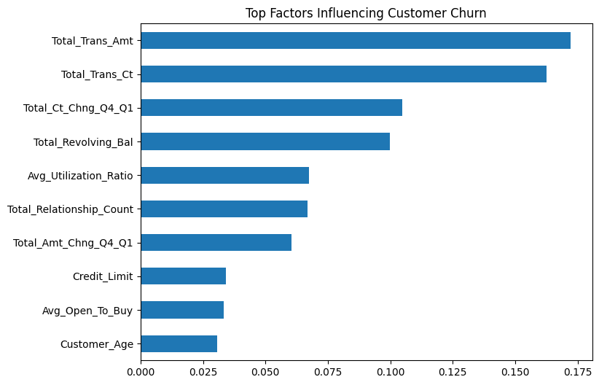
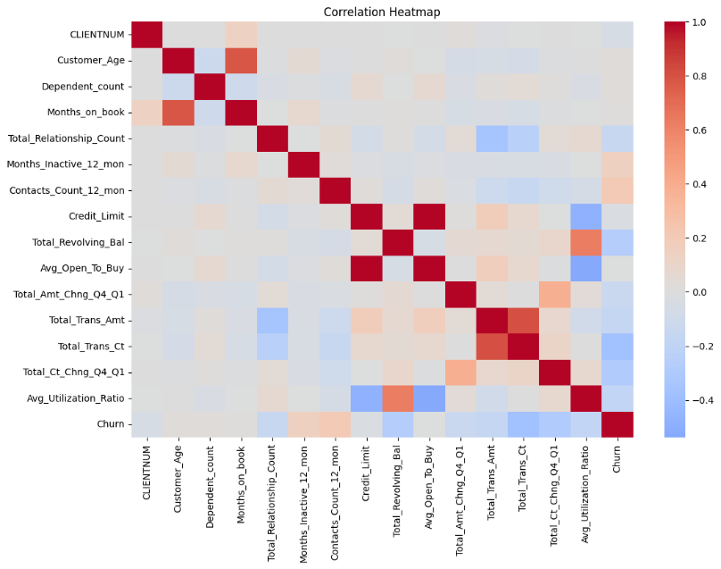
Different visualization techniques like were created in Python to analyze correlations between variables and churn.

Figure 2 Top Factors influencing churn

Figure 1 Correlation Heatmap Credit Card

Telecom Industry:
From EDA using Python, it was found that:
- Monthly contract customers churn at a very high rate
- A higher monthly fee was linked to churn
- Shorter tenure customers are most prone to churn
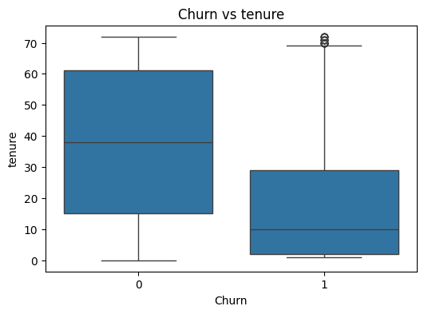
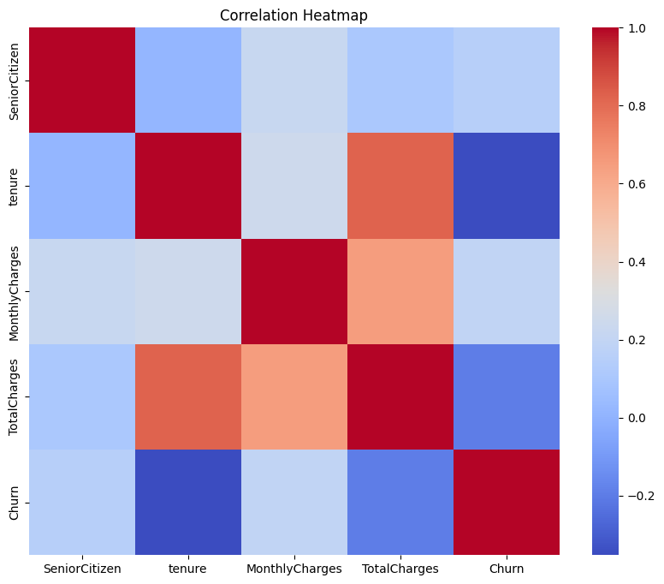
Using Python visualization tools such as heatmap, boxplot plots revealed issues like class imbalance and customer behavior in comparison to other customers.
Figure 4 Boxplot
Figure 3 Correlation Heatmap Telecom
SaaS Industry:
Because of the multiple table format, Python was widely applied for data summarization and analysis. Important findings include:
- Low utilization of features increased likelihood of customer churn
- High number of support tickets were associated with dissatisfaction and churn
- Patterns of subscription usage were key factors determining customer churn
Using feature engineering in Python helped produce metrics at the level of individual accounts, thus improving the quality of data analysis.
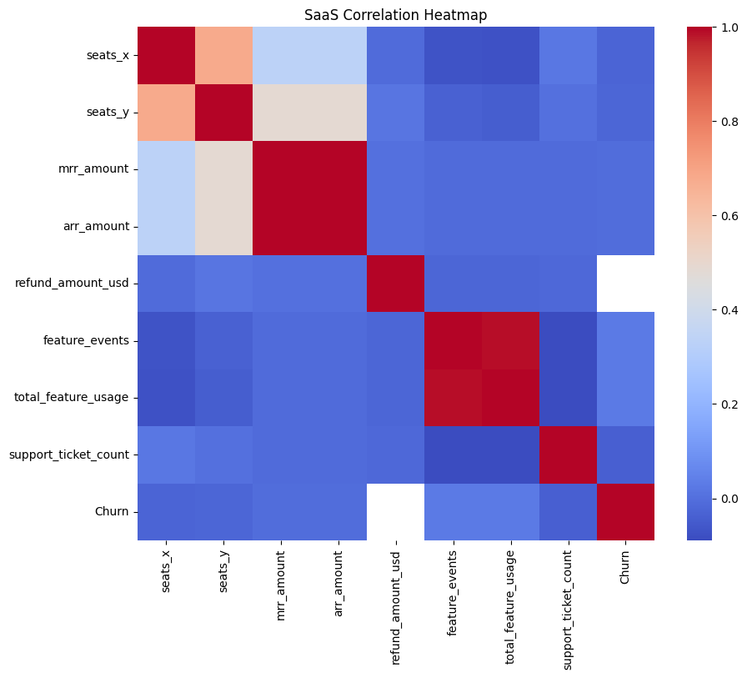
Figure 5 Correlation Heatmap- SaaS
Predictive Modeling (Python Implementation)
Prediction modeling was carried out in Python using the Scikit-learn package. There were three supervised learning models applied to all three data sets as follows:

Logistic Regression
- Used as a base line model
- Provided interpretation of feature significance
- Helped understand what influenced churn
Decision Tree
- Permitted customer segmentation using rules
- Allowed decision making
- Could capture non-linear relationship
Random Forest
- Best model for prediction performance
- Performed better by mitigating over-fitting
- Used feature importance scoring to rank features
Models were assessed based on the following parameters:
- Accuracy
- Precision
- Recall
- F1 score
- ROC-AUC
The use of Python ensured that classification reports, confusion matrices, and ROC plots were generated for thorough model evaluation.
Model Performance Comparison:
In all three sectors, Python model analysis indicated the following:
- Random Forest was always the best in terms of accuracy.
- Logistic regression was good when it came to explaining predictions.
- Decision tree performed moderately well, but could be easily interpreted.
In conclusion, although complex algorithms can enhance accuracy, their explainability is also very important.
Risk Segmentation:
Customer segmentation based on predicted churn probabilities using the Random Forest model included the following segments:

- Low risk
- Medium risk
- High risk
The churn risk data set was generated using Python and later embedded in Power BI dashboards.
Visualization Result:
Cross Industry Result
The cross-industry dashboard included the following measures: number of customers , number of customers, churn rate, average revenue and risk-based customers. According to the output of the built dashboard. SaaS had the highest churn rate, while Telecom exhibited moderate churn and Credit Card had lowest churn rate. As to average revenue per customer, the dashboard indicated that Credit Card has the highest indicator, then SaaS and Telecom was lower. Such comparison implies as important business insights as the lowest industry with the highest churn rate does not automatically have low revenue per customer.
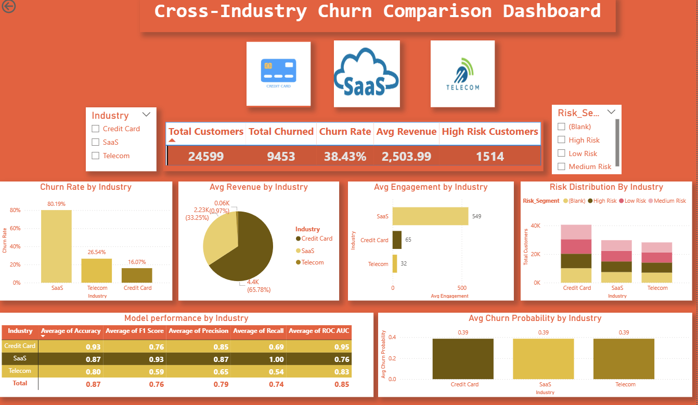
In turn, the cross-industry model-performance panel revealed the differences among datasets. It can be stated that the model performance varied for different industries as expected because the predictor structure varied greatly. Nonetheless, it should be mentioned that the findings support the general conclusion of the project regarding the comparison of models where the Random Forest performs well whereas Logistic Regression and Decision Tree may still be used based on tradeoffs. It was also proved that churn probability average and distribution could be used for industries' comparison on a business-level summary basis.
Figure 6 Cross Industry Churn Comparison Dashboard
Software-as- Service (SaaS) Results:
The SaaS dashboard highlights the presence of an extremely high churn environment. In the KPIs section, there were many churned accounts compared to retained accounts, resulting in a churn rate of around 80%. While part of this may be due to the nature and composition of the dataset selected, it is a very suitable area to study the causes of churn. The SaaS dashboard suggested that feature usage and support interactions were relevant dimensions for analyzing churn factors. Less active clients who exhibited some forms of support behavior were prone to churning, consistent with the findings from the EDA and other studies on SaaS churn.
The SaaS dashboard also displayed the churn rate for each industry category within the SaaS data set, including cybersecurity, developer tools, edtech, fintech, and health technology. This segmentation demonstrates the variability in churn behavior even within SaaS. As seen in the risk segmentation visualization, the number of high-risk clients was relatively high, indicating that the client-success team needs to focus more on behavioral risk rather than subscription status.
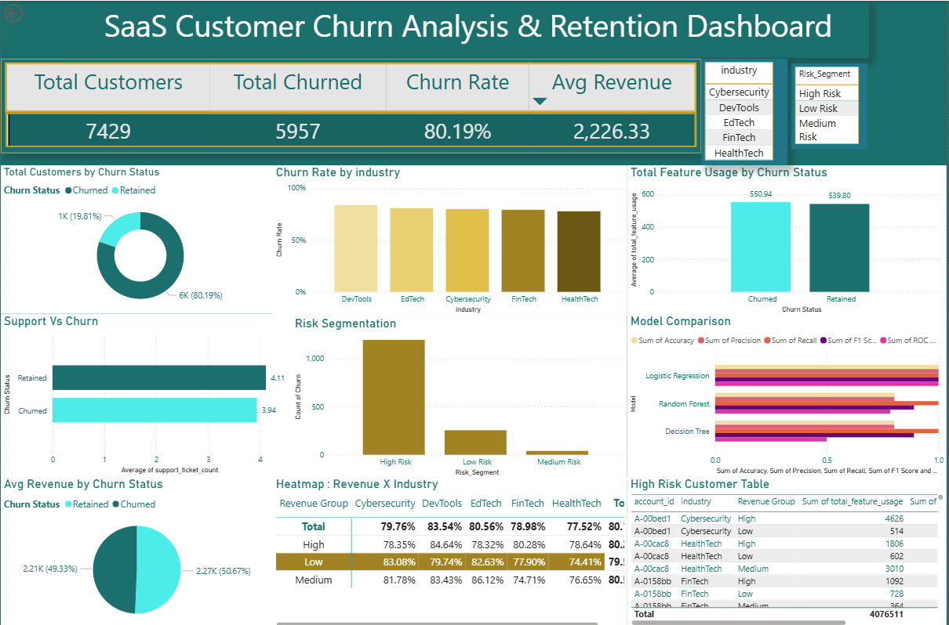
Based on the performance comparison chart on the SaaS dashboard, it is clear that performance was relatively high across all chosen models, with particular emphasis on recall-based churn detection. In a managerial context, this implies that a SaaS company can develop an actionable early warning system from the products and services used, and subsequently roll out onboarding or customer success campaigns.
Figure 7 SaaS Customer Churn Analysis & Retention Dashboard

Telecommunication Result:
From the Telecom Dashboard, the churn rate was found to be about 56%. It can also be observed that churn was linked to month-to-month contract terms and relatively short tenure. From the visuals on the contracts, it was determined that month-to-month users have a higher probability of churning compared to other contracts. This is a typical churn trend for telecommunications companies and has been supported by past literature as well. Contract terms have been shown to be one of the best predictors of telecom customer churn in previous studies. (Nurulhuda Mustafa, 2021)
Other characteristics related to the telecom industry were also observed from the visuals. Churners had a higher monthly charge, and it was evident from the visuals that tenure was greater among retained customers. These results indicate that billing pressure and poor contract commitment are some of the factors that increase the probability of defection.
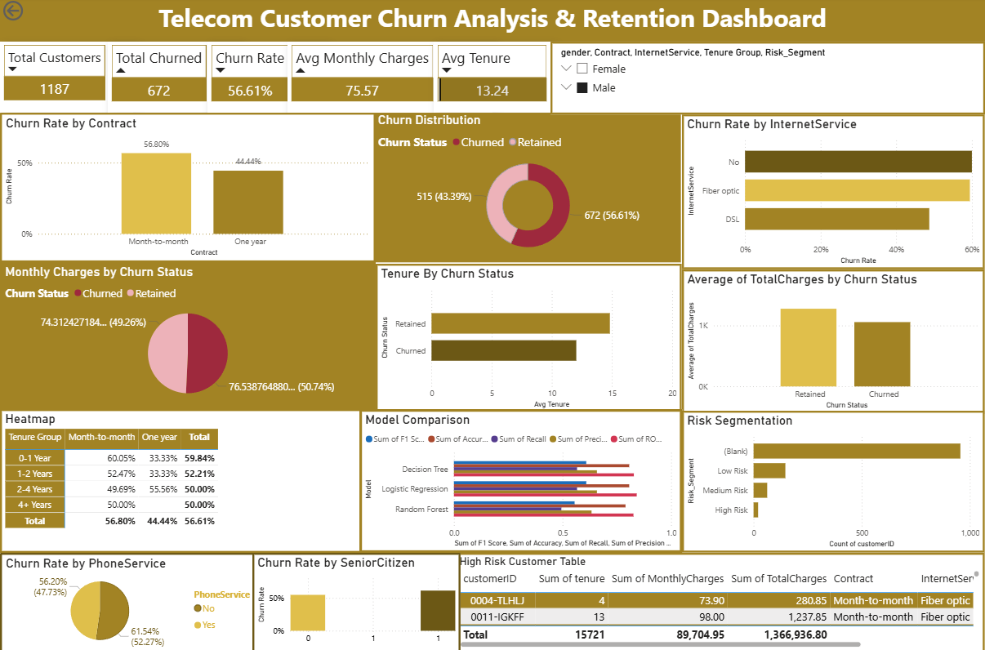
Regarding modeling performance, the telecommunications models showed satisfactory performance in their comparisons. While there were differences in metrics' strength depending on accuracy, recall, and precision, the models had good enough discriminative ability to segment customers into different groups. In the high-risk group identified by the telecom model, there was evidence of high monthly fees, shorter tenures, and certain types of contracts. This helps strategically because it allows more targeted actions, such as offering contract conversions, bill optimizations, or loyalty rewards.
Figure 8 Telecom Customer Churn Analysis & Retention Dashboard
Credit Card Result:
Among the three industries analyzed, the Credit Card exhibited the lowest churn rate at approximately 16%. Despite the low overall rate, churn cannot be overlooked in any industry, especially where the loss of customers is financially expensive since the churned client might be a valuable one in terms of transactions or even profitability. Indeed, churn was observed to differ according to various categories of cards and income levels on the credit card dashboard.
From the analysis of the credit card industry, two important observations were obtained. One, churned customers had lower transaction volume and less customer engagement compared to retained customers. Two, credit limit and customer values for churned customers were different from those for retained customers. These observations were consistent with the theory presented in the mid-term report in that low transaction volumes were important signs of churn.
According to the performance of the models in the credit card dashboard, there is high predictability especially when it comes to Random Forest, whereas both Decision Trees and Logistic Regression were also beneficial. The table of high-risk customers gives an operational perspective of high-risk customers, which is essential in the banking sector as these kinds of customers can be rewarded through special schemes and campaigns.
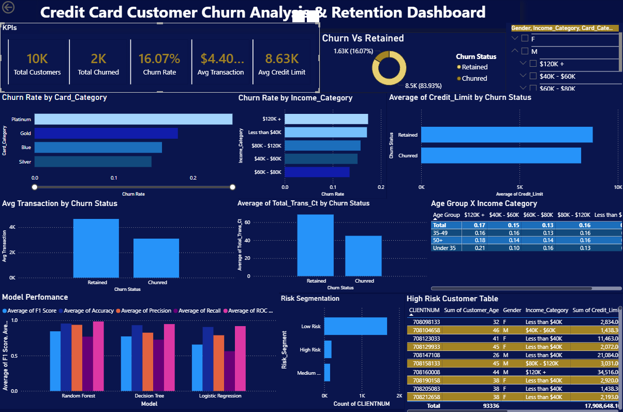
Figure 9 Customer Churn Analysis & Retention Dashboard

Comparative Interpretation of Results
All these results lead to one of the main conclusions of the entire research, which states that churn is a common business issue, but it depends significantly on structural factors in different industries. Thus, for a SaaS product, behavioral factors inside the ecosystem become the strongest predictors. For telecoms, price and contract structures matter a lot. Lastly, for credit card providers, engagement and customer value metrics are important.
It was already stated that the utility of a model should not be measured in terms of one factor only. High accuracy does not equal high utility because low recall will result in insufficient detection. On the other hand, better recall rates can be considered more valuable in the case of early detection purposes. Thus, a multi-metric evaluation method chosen for this project becomes crucial. It supports the literature recommendations regarding churn detection models. (Mehdi Imani ORCID, 2025)
One other important outcome that needs to be highlighted at this stage is the importance of using dashboards. There was a transition in the current assignment from data and results obtained through machine learning algorithms to information that can be presented visually for business use including key performance indicators, churn rates, risk categories, and risky customers. The importance of this process is clear since decisions regarding retention are not typically made through code results.

Discussion and Insights
The findings from this particular study confirm the broader business analytics principle that customer churn is not an all-encompassing phenomenon. Although we can often talk about churn in generic terms, there are clear variations in its operational definition depending on the specific business model being considered. As seen from the current case study, even if one uses the exact same analytical approach in different industries, the factors leading to churn tend to differ from sector to sector.
Specifically, when it comes to the SaaS industry, the current study seems to indicate an adoption-oriented interpretation of churn. Those customers who are not actively involved in using the product or those who repeatedly seek support but don't use the product much are more prone to churn. The finding means that customer churn in SaaS companies can be understood in terms of product experience and success. For such companies, churn cannot be viewed exclusively as a financial issue since it also entails issues with product experience. (Muhammed Kotan, 2025)
For Telecom, the finding indicates a model based on contract and pricing factors. Customers with a month-to-month contract, short period of stay, and high monthly fees are more likely to churn. Thus, the implication is that customer churn increases as the relationship with the company becomes structurally weak and easy to quit economically. For management, this is an indication that customer retention in telecom is equally about pricing design and contract as it is about product quality. Literature supports that telecom churn is also driven by switching behaviors, competition, flexible contracts, and billings. (Nurulhuda Mustafa, 2021)
For Credit Card companies, the findings indicate that churn is driven by the level of engagement and value derived. Usage count and activity become more important than mere demographics. In other words, a customer may quietly start churning without a change in account status. This is especially crucial for prediction and monitoring as there are no significant changes in account status. It will be useful for companies to keep track of financial engagement through customer activity to prevent loss. This perspective is consistent with banking and credit card attrition research which focuses on behavioral changes. (Dana AL-Najjar, 2022)
Among the key cross-project findings, one could name that predictive modeling is highly efficient in combination with business segmentation. Probability scores alone were not sufficient for decision-making; the categorization of outputs into low-, medium- and high-risk groups made their usage more feasible. It helped dashboards to answer such queries like which clients should be approached first, which segments can be considered stable, where the budget for client retention would be best to invest. Such an approach turns analytics into practice rather than simply providing a description of what is going on.
Another key lesson learned from the projects is the value of interpretability. Random Forest proved to work very efficiently in many cases, which aligns with the existing literature on churn prediction benchmarks. Yet at the same time, Logistic Regression and Decision Tree models are still relevant in the context of applied analytics since it is essential for stakeholders to understand the patterns behind predictive models. Thus, while building an analytics solution, it is crucial to focus on both efficiency and comprehensibility of a chosen model. (Arno De Caigny, 2018)
Additionally, the move from Tableau to Power BI provides valuable lessons in project management. Sometimes, restrictions, compatibility challenges, and deadlines in the analytical process influence the selection of tools used. The transition to Power BI allowed the project to preserve its reporting objectives and enhance the efficiency of the final dashboard execution. It proves that one is capable of adaptation and adds to the relevance of the research, showing how analytical processes usually work.
Another topic to consider in the concluding part of this project is the use of comparative analytics itself. Usually, in studying the issue of customer churn, researchers focus on one industry. Consequently, their results may lack generalizability. However, by exploring three industries, one proves that the use of one single methodological tool can be quite effective in studying completely different types of data.

Recommendations
From the detailed analysis performed using Python and Power BI tools to predict and visualize trends, various practical and actionable recommendations have been put forth for the SaaS, Telecommunications, and Credit Card industries. Such recommendations are derived based on observable behavior trends and predictions and can be effectively implemented.
SaaS Recommendations:
The results obtained show that low usage of features and high levels of interactions with support staff are factors that contribute significantly to customer churn within the SaaS industry.
To begin with, companies operating in the field of SaaS need to concentrate on encouraging clients to adopt all the available features and undergo the entire onboarding process. The findings obtained show that clients who fail to utilize important features and undergo onboarding are likely to leave at an early stage. Therefore, companies could invest in developing interactive onboarding systems and guided tutorials to increase engagement.
Second, the findings show that customers who interact often with support staff and then churn could be considered a red flag. Thus, organizations need to find ways of identifying these customers and offering personalized customer success services, such as appointing an account manager or providing special support services.
Third, SaaS need to use a risk-based approach for customer retention with the help of output from churn prediction. High-risk customers who are predicted as such by using machine learning algorithms need to be retained via retention programs that include discounting, upgrading products, or offering personalized assistance. Customers in the medium risk category may be retained using education about product features.
Telecommunications Industry
From the telecom data, churn was highly dependent on contract, pricing, and customer tenure, whereby customers who had month-to-month contracts and high monthly payments were more at risk.
A vital recommendation is that companies ensure their customers use a contract-based subscription package. Customers using month-to-month plans have high risks of churning because of the ease of switching services. Telecom companies should consider offering their customers discount offers that will lure them into signing longer contracts.
Price optimization is another approach that telecom companies need to undertake. From the analysis, those customers paying high monthly prices had increased risks of churning since they are price sensitive. Telecoms should ensure that they offer attractive discounts to their high-paying but low tenured customers.
Telecom companies also need to implement an early warning system for identifying potential churners in the first few months of service. Since the risk of churn increases with tenure, it is advisable that telecoms initiate an early warning process within these periods.
Credit Card Industry:
In the case of the credit card industry, churn is related to low transaction volumes, lower engagement levels, and variations in customer categories, which implies that behavioral changes are the initial predictors of churn.\
First, financial institutions are recommended to improve customer engagement by introducing various incentive programs. The customers with decreased transaction volumes will be incentivized through providing cashback, bonus points, or spending-related incentives that encourage customers to use their credit cards more frequently.
Second, special attention needs to be paid to the customers who generate significant revenue but show lower churn propensity rates. Since the average rates of churn are small in this case, losing customers who generate large sums of money may lead to serious financial implications for the organization. Therefore, customers with large credit limits but low transaction rates need to be approached and offered additional incentives.
Finally, organizations are advised to monitor customer behavior for early prediction of churn. Changes in the customer's spending behavior should serve as warning signals that can be used to initiate proactive actions.
Cross-Industry Recommendations
In all three industries, there were several common points that came up during the research process, showing that it is important to connect predictive analytics to business strategy.
Firstly, businesses need to consider implementing machine learning churn prediction technology into their activities. The research proved that the Random Forest algorithm can be used to detect the likelihood of churn and make predictions. Such models have to be introduced in business activities and improved by adding data to them regularly.
Secondly, it is crucial to consider customer risk segmentation as a major part of retention strategies. Businesses have to segment their clients into low-, medium-, and high-risk groups. While customers at high risk should be addressed immediately, those at medium risk can become targets for targeted campaigns, whereas those at low risk can be retained via good services.
Thirdly, companies need to pay attention to decision-making based on dashboards. During the project, Power BI dashboards for visualizing churn rate, customer behaviors, and prediction results were created. Businesses will benefit from including such tools in their processes.
Fourthly, it is essential to continue working on predictive models by tuning hyperparameters, testing other machine learning algorithms, and introducing real-time data.
Strategic Insight
One important conclusion reached from the above discussion is that customer engagement is the single most important determinant of churn rate across various industries. Although different factors affect the churn rate depending on the industry—feature usage in the SaaS industry, price changes in the telecommunication industry, and transaction activities in the credit card industry, the common thread runs through the fact that disengaged customers tend to churn more often.
Thus, it would be prudent for companies to focus on engagement-enhancing tactics such as improving customer experience and personalized communications.

Limitation and Future Work

The present research study has various limitations. Firstly, the datasets used in the current paper were public datasets downloaded from Kaggle. While these datasets are acceptable for conducting an analytical study and providing valuable insights into customer churn, they are not live datasets from actual companies. Thus, their application in the study does not guarantee generalization to all companies because they lack the same degree of complexity and structure as actual enterprise datasets.
Secondly, the three datasets used in the study have different structures and levels of variable granularity and industry logic. While the research applied a unified analytical pipeline for comparing them, there was no way to ensure that all variables have equal meaning across industries, which is one of the most important issues associated with cross-industry churn studies. The difference in variable meaning should be taken into account when comparing churn models for various industries.
Lastly, the research study analyzed only three algorithms: Logistic Regression, Decision Tree, and Random Forest. While all three algorithms provide high quality and robust results, the study could have applied more advanced machine learning methods, such as gradient boosting, XGBoost, LightGBM, CatBoost, and even artificial neural ne (Delaere, 2023)tworks.
Fourth, this research concentrated on structured data presented in tables. Further analysis can involve adding more features related to time series behavior, information from customer support communications, history of campaigns and responses to them, or events sequences. This may be useful in the context of SaaS and telecom where customers' activities occur continuously.
Finally, it was necessary to move the development of the dashboards from Tableau to Power BI due to problems encountered during implementation. Although it did not impact the analysis itself, changing a visualization tool is considered an important step in developing the final deliverables.
Potential areas of future research include, but are not limited to, conducting hyperparameter tuning and cross-validation more thoroughly for every dataset; performing more analysis using XAI tools like SHAP values; estimating the value that can be gained in terms of financial profit by predicting customer churn and initiating retention campaigns; and testing the proposed approach on actual organizational data of at least one company from the subscription business.

References
Arno De Caigny, K. C. (2018, September 08). A new hybrid classification algorithm for customer churn prediction based on logistic regression and decision trees. European Journal of Operational Research,, 269(2), 760–772. Retrieved from A new hybrid classification algorithm for customer churn prediction based on logistic regression and decision trees: https://www.sciencedirect.com/science/article/abs/pii/S0377221718301243
Dana AL-Najjar, N. A.-R.-N. (2022). Machine learning to develop credit card customer churn prediction. Journal of Theoretical and Applied Electronic Commerce Research, 17(4), 1529-1542.
Delaere, M. B. (2023). Ensemble Methods in Customer Churn Prediction: A Comparative Analysis of the State-of-the-Art. Mathematics, 11(5), 1137.
Delaere, Matthias Bogaert and Lex. (2023). Ensemble Methods in Customer Churn Prediction: A Comparative Analysis of the State-of-the-Art. MDPI, 11(5), 1137.
Mehdi Imani ORCID, M. J. (2025). Customer Churn Prediction: A Systematic Review of Recent Advances, Trends, and Challenges in Machine Learning and Deep Learning. MDPI, 7(3), 105.
Muhammed Kotan, Ö. F. (2025). A novel methodological approach to SaaS churn prediction using whale optimization algorithm. Scientific Reports.
Nurulhuda Mustafa, L. S. (2021, December 13). Customer churn prediction for telecommunication industry. Retrieved from PMC Pubmed Central : https://pmc.ncbi.nlm.nih.gov/articles/PMC9051585/
Samira Khodabandehlou, M. Z. (2017). Comparison of supervised machine learning techniques for customer churn prediction based on analysis of customer behavior. Journal of Systems and Information Technology, (1-2): 65–93.
Sarkaft Saleh, S. S. (2023). Customer retention and churn prediction in the telecommunication industry. Heliyon / PMC indexed article, 5(7):173.
Shrestha, S. (2026). Data Acquistion & Preparation Report . Fairborn .
Shrestha, S. (2026). Mid Semester Check Point Evaluation Report . Fairborn.
Shrestha, S. (2026). Proposal of Capstone Project . Fairborn .

Appendices

Appendix A : Python Code

Credit Card Industry
Data Transformation | ETL | Transform Variables
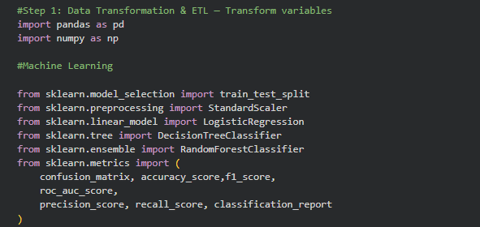
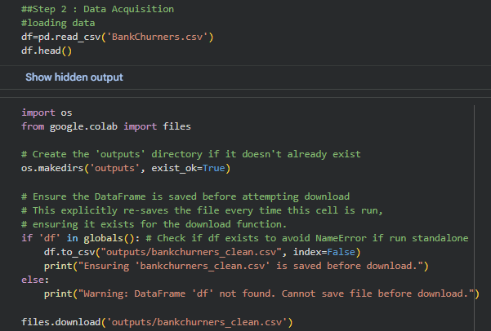
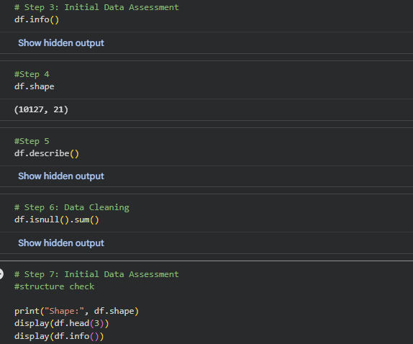
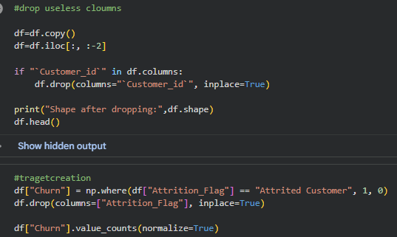
Data Cleaning and Handling Missing Values
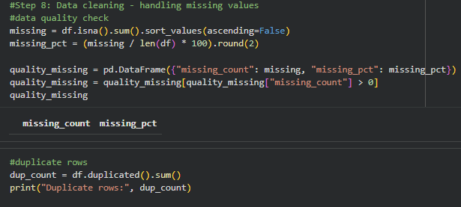
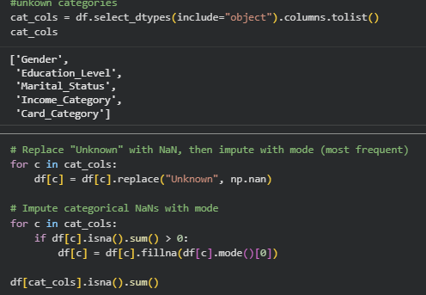
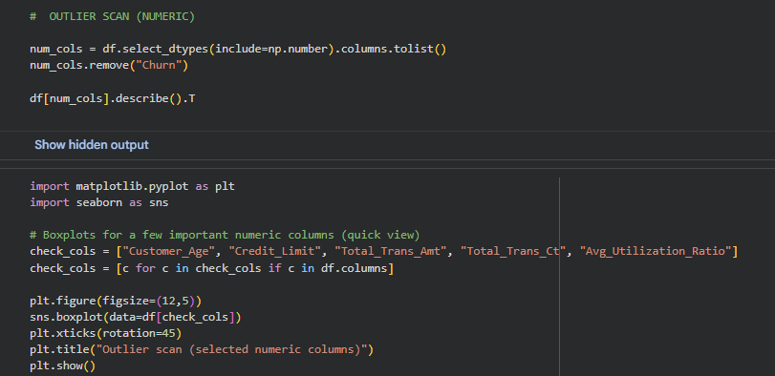
Data Dictionary
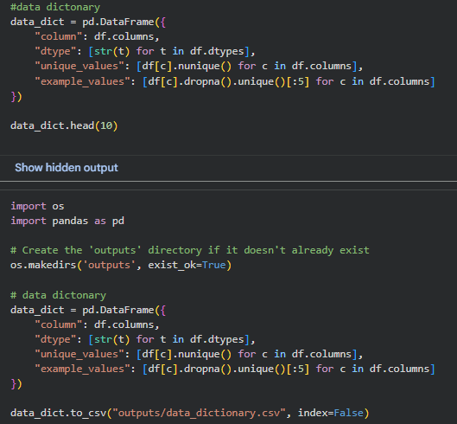
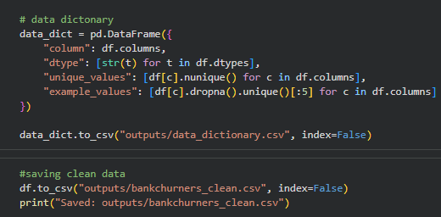
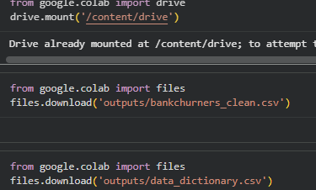

Exploratory Data Analysis
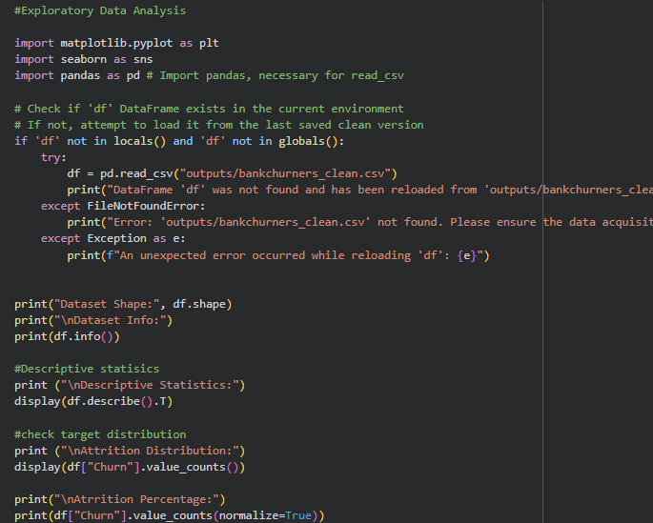
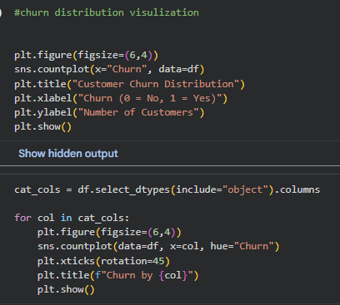
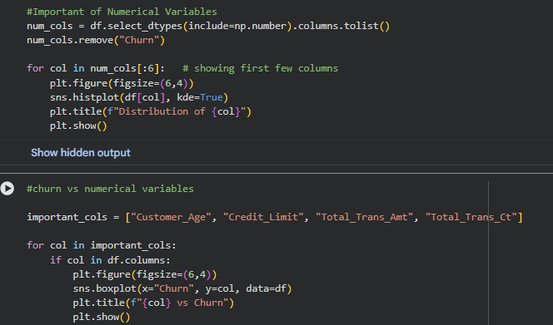
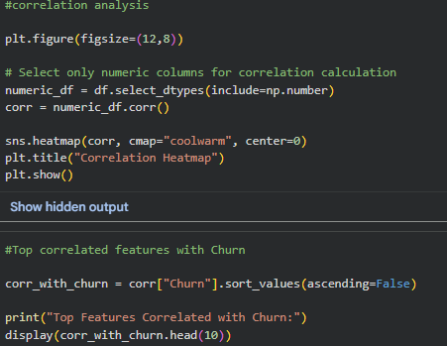
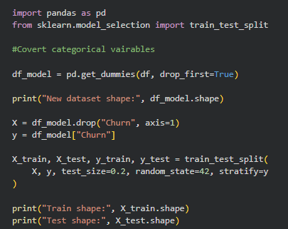
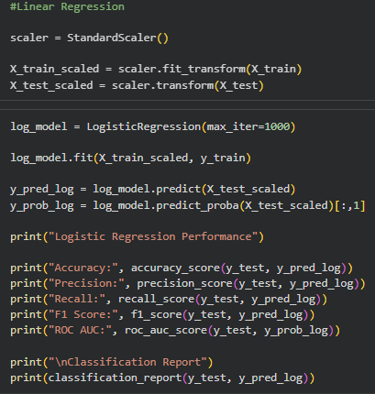
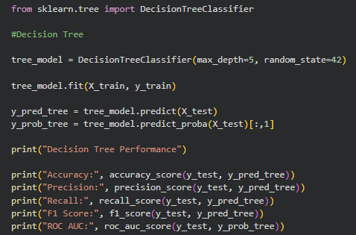
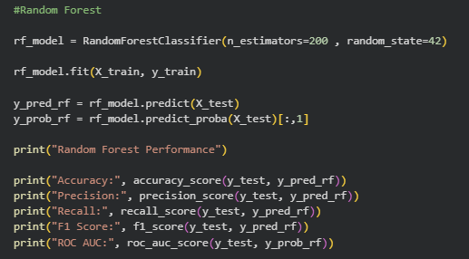
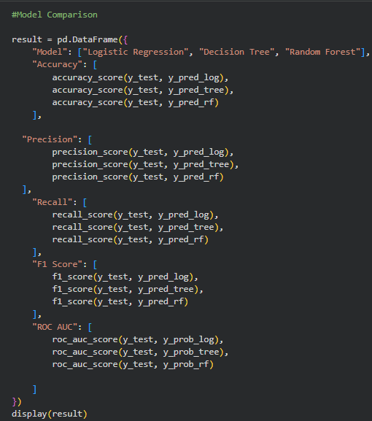
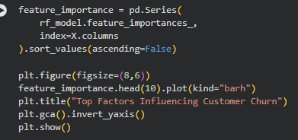
Risk Segmentation
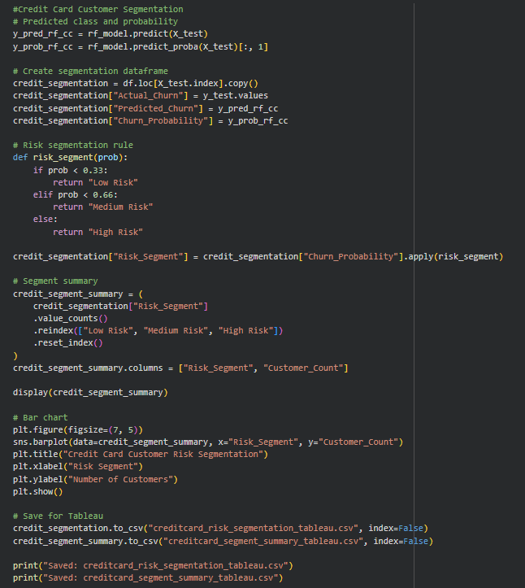
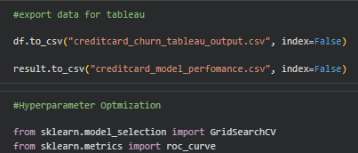
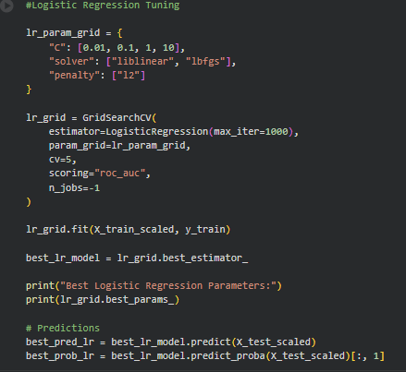
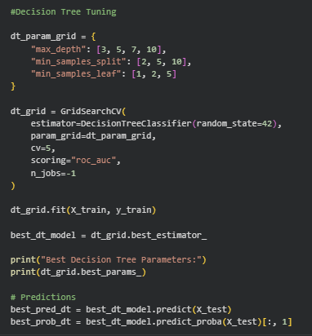
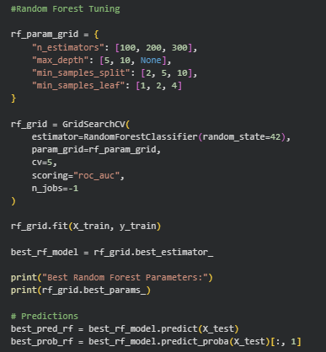
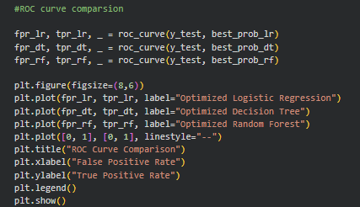

Telecommunication Industry

Data Transformation | ETL | Transform Variables
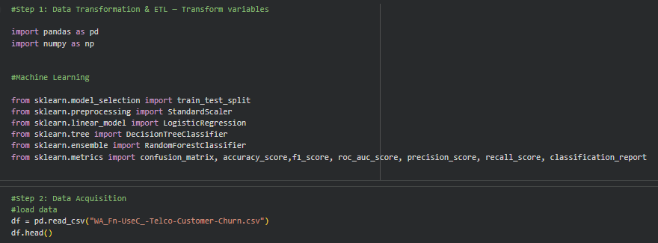
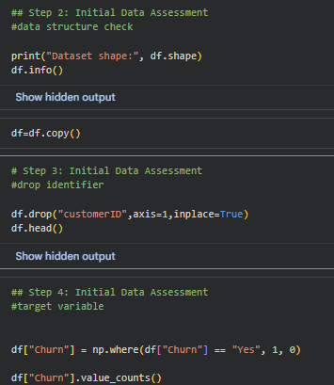
Data Cleaning | Handling Missing Values
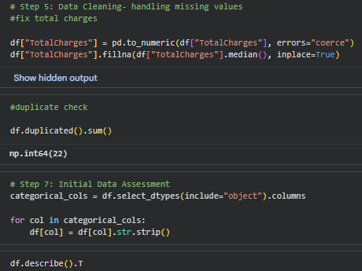
Data Dictionary
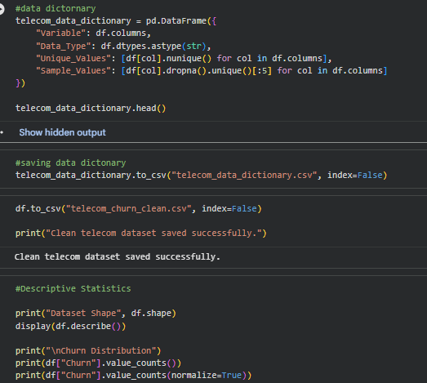
Exploratory Data Analysis
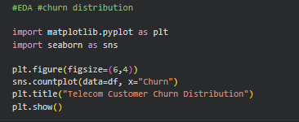
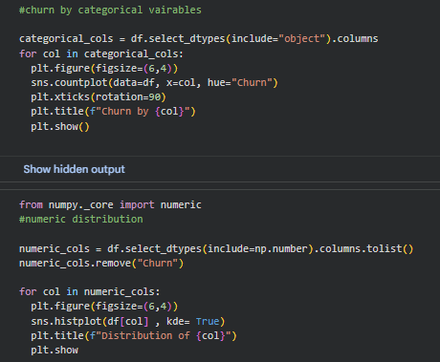

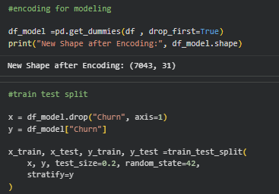
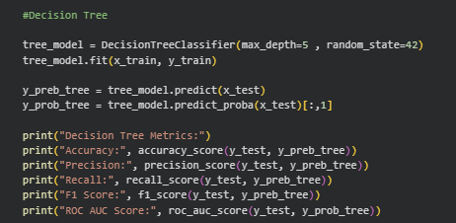
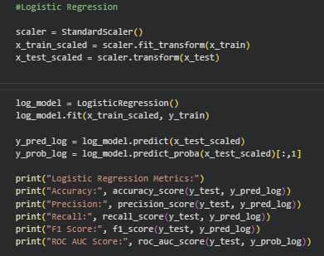
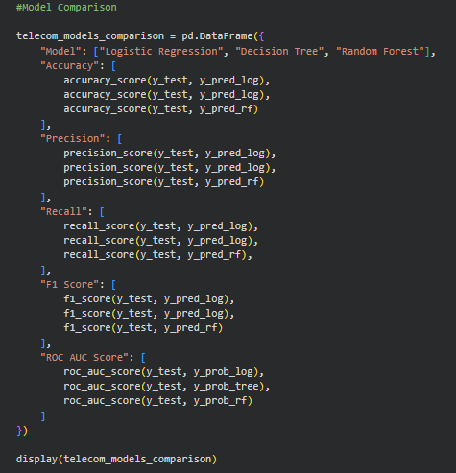
Risk Segmentation
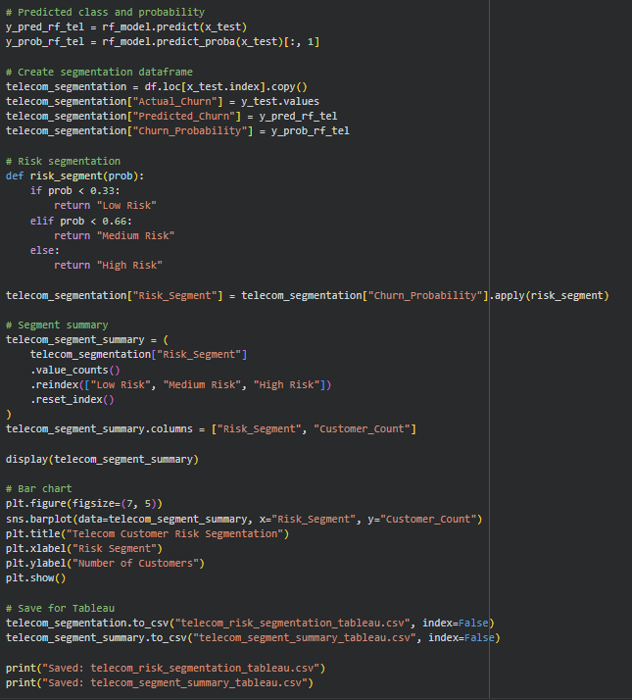
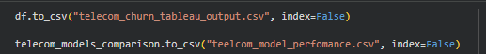

Hyperparameter Optimization
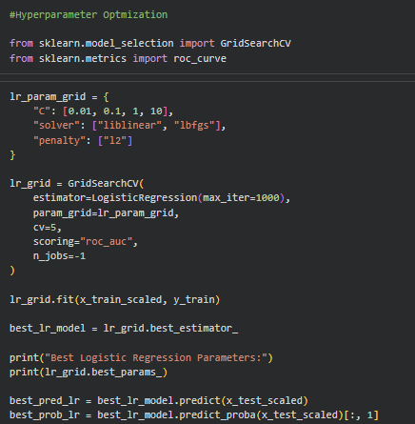
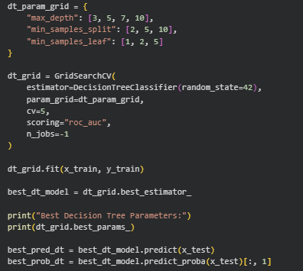
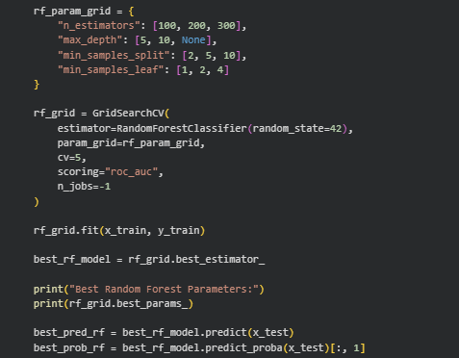
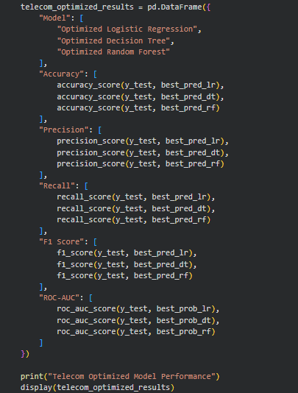

SaaS Industry
Data Transformation | ETL | Transform Variables
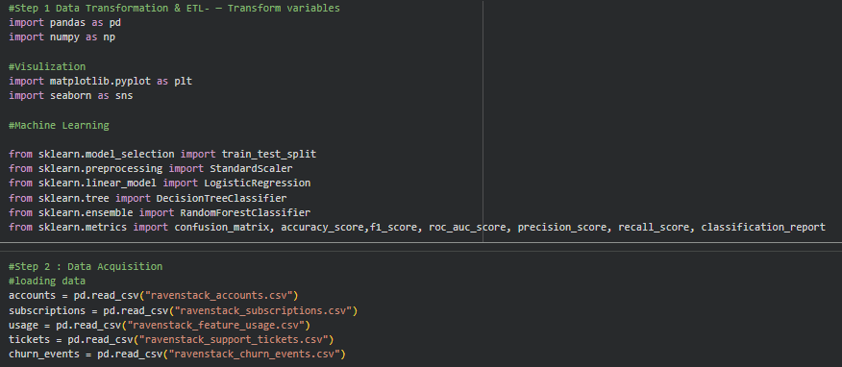
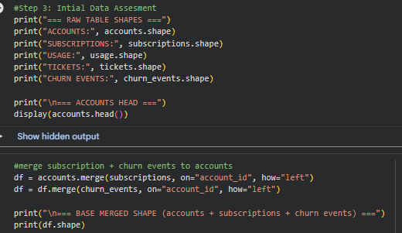
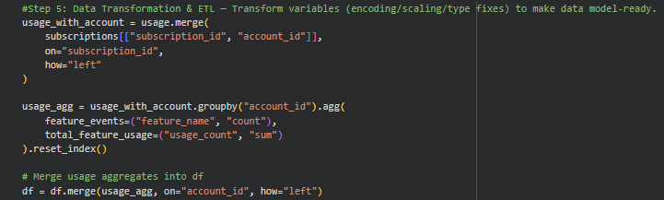
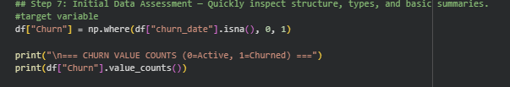
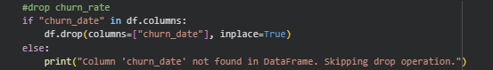
Data Cleaning and Handling Missing Values
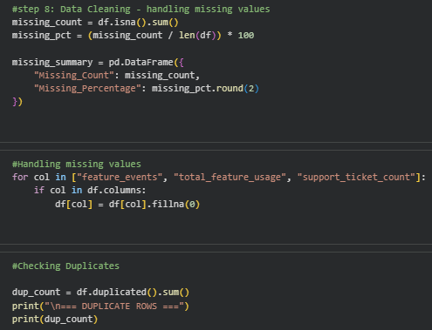
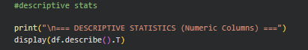
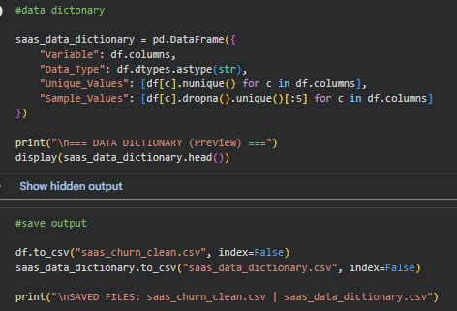
Data Dictionary
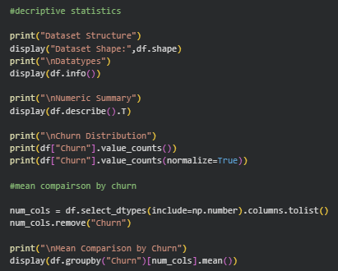
Exploratory Data Analysis
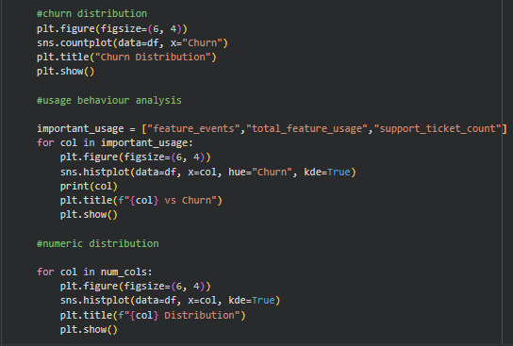
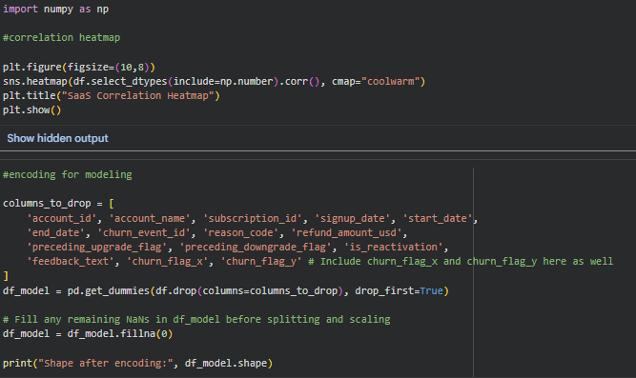
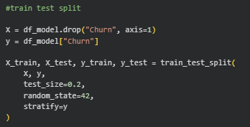
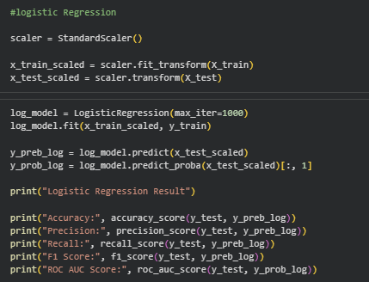
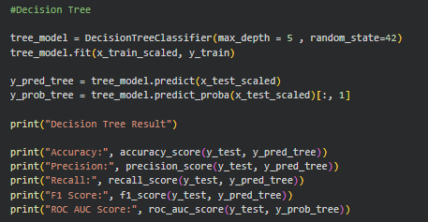
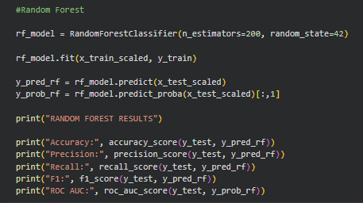
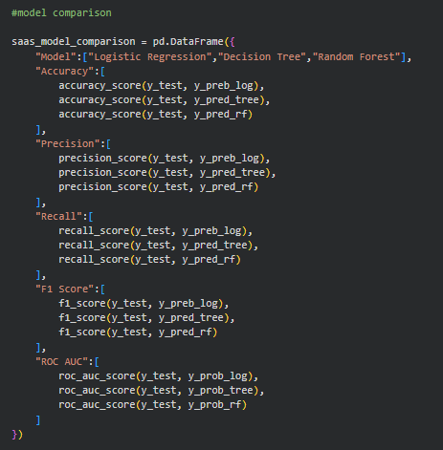
SaaS Customer Segmentation
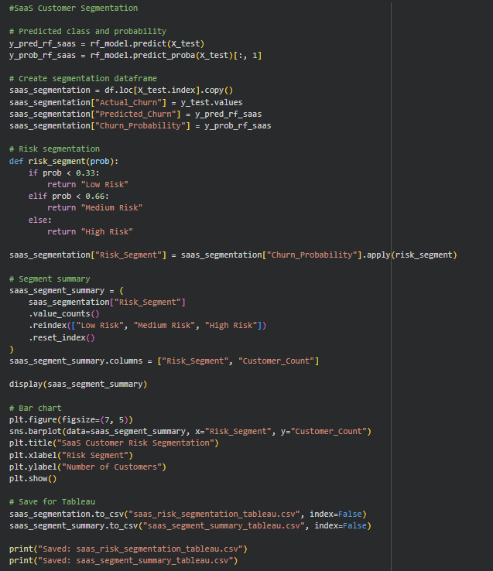
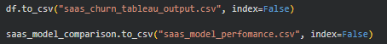
Hyperparameter Optimization Tuning
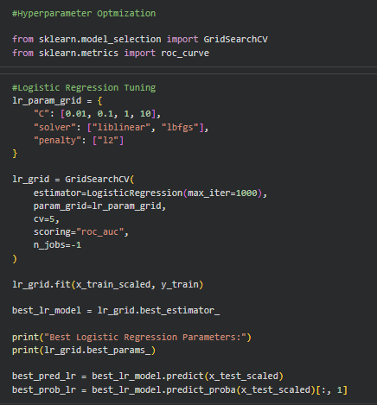
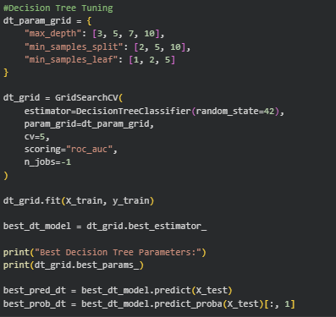
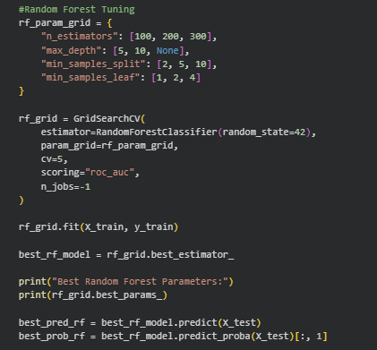
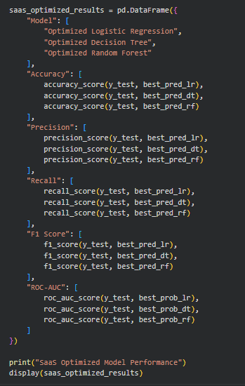

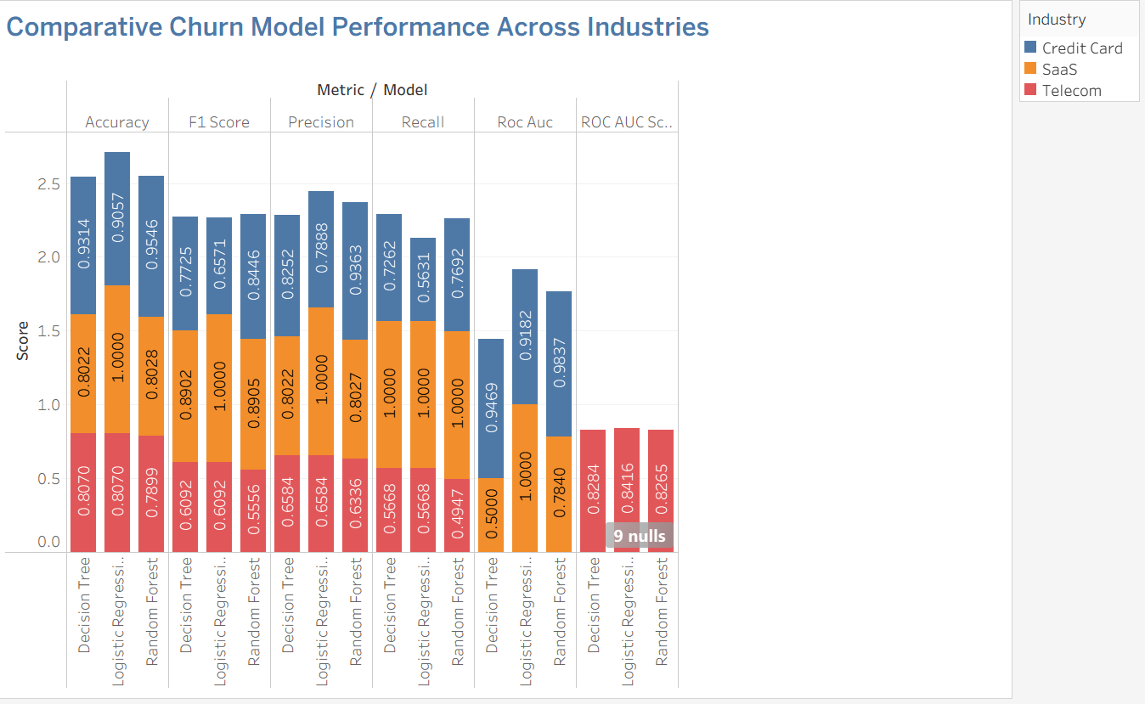
Appendix B: Visualization
Fig 1: Visualization In Tableau (When Tableau was functioning later all visualization shift to Power BI)- Model Comparison across Industries
Some Visualization done in Python

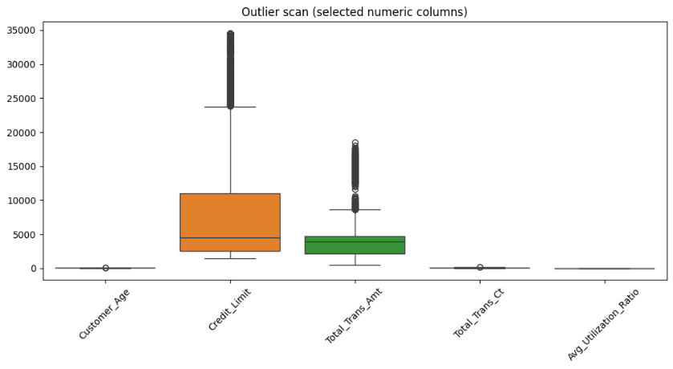

Credit Card Industry
Fig 2: Boxplot for few numeric columns and Factors Influencing Churn

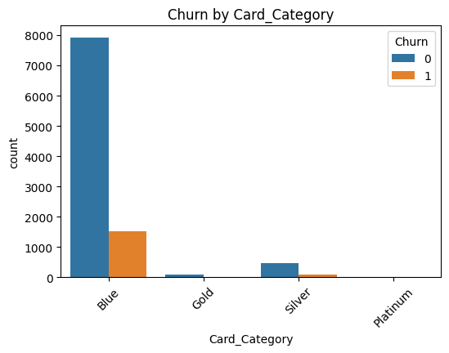
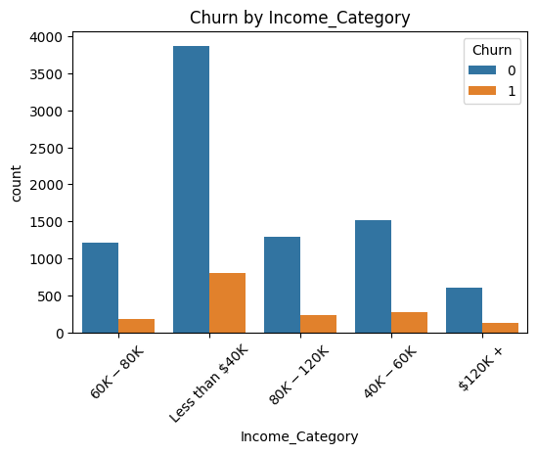
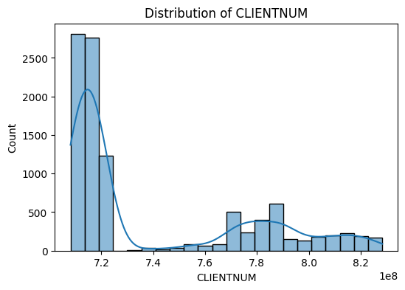
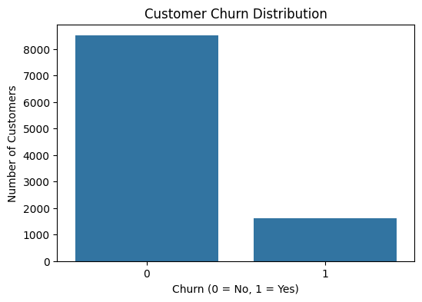
Fig 3: Customer Churn Distribution Fig 4 : Churn By Income Category
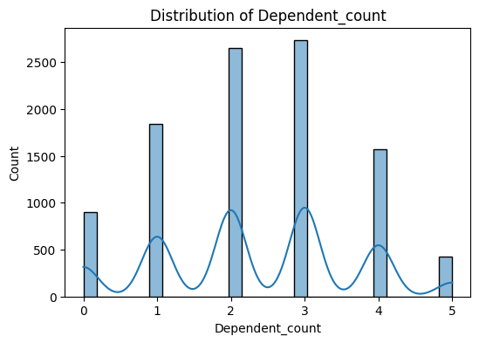
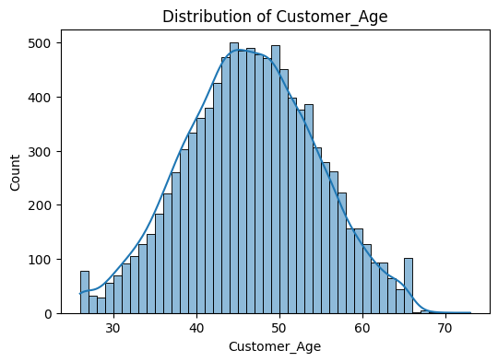
Fig 5: Churn By Card Category Fig 6: Distribution of Customer
Fig 8 : Distribution of Dependent Count 1
Fig 7 : Distribution of Customers

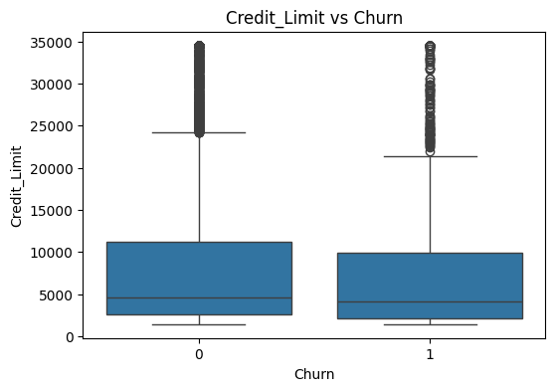
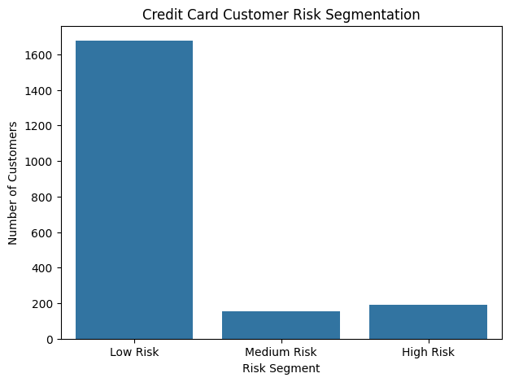
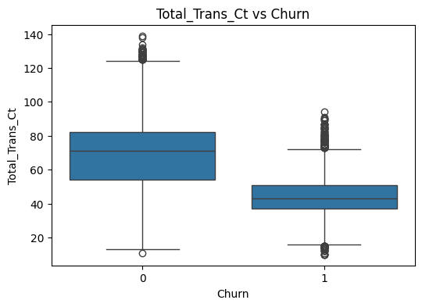
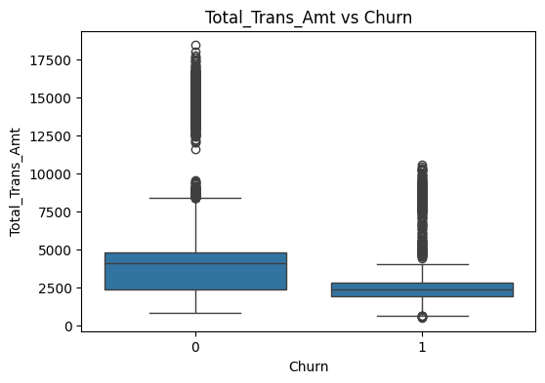
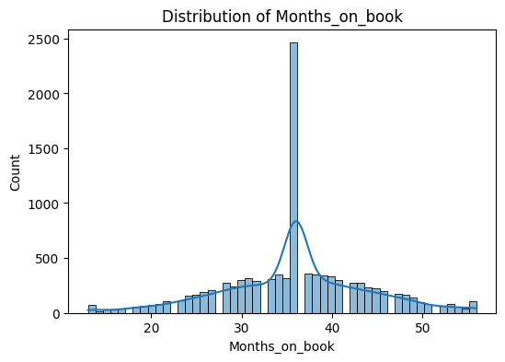
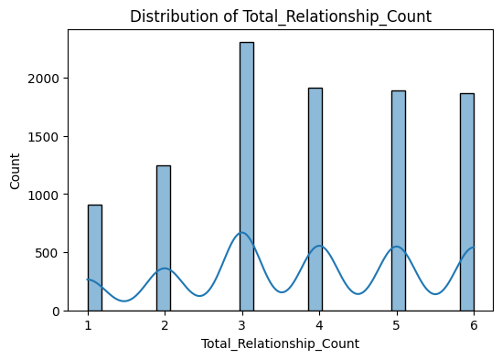
Fig 13 : Total Trans Amt Vs Churn
Fig 14: Credit Card Risk Segmentation
Fig 12: Total Trans Amt Vs Churn
Fig 11: Credit Limit Vs Churn
Fig 10: Distribution of Months on Book
Fig 9: Distribution of Total Relationship Count


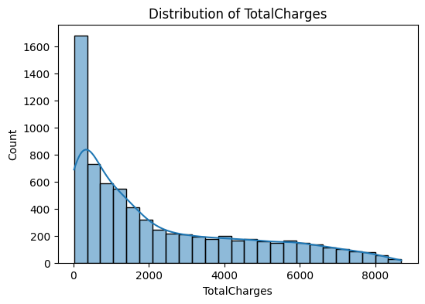
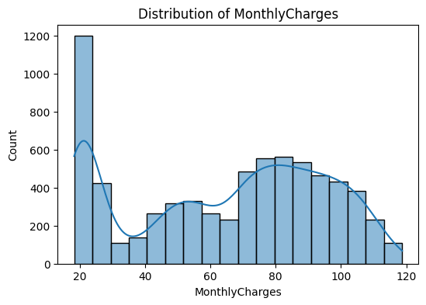
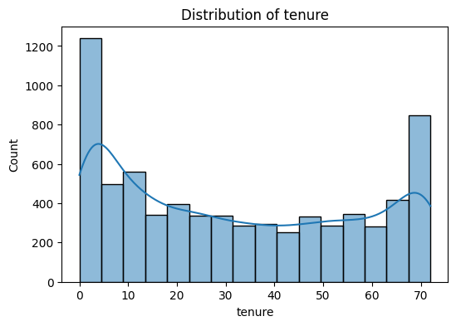
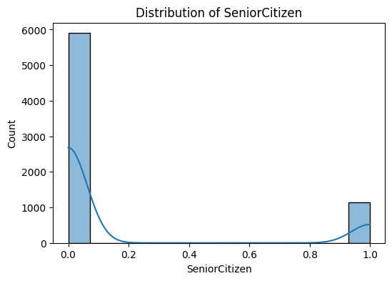
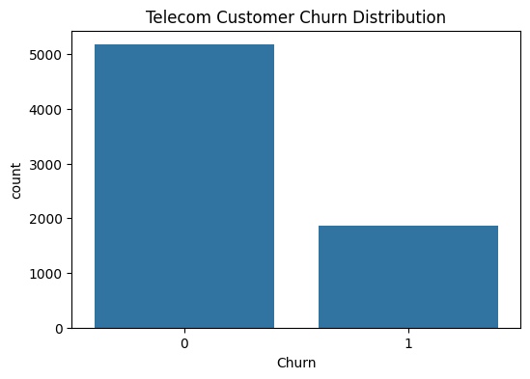
Telecommunication Industry
Fig 17: Distribution of Tenure
Fig 20: Churn VS Tenure
Fig 16: Distribution of Senior Citizen
Fig 19: Distribution of Total Charges
Fig 18: Distribution of Monthly Charges
Fig 15 : Telecom Customer Churn Distribution
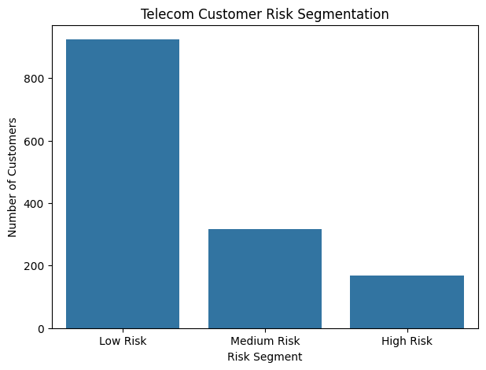
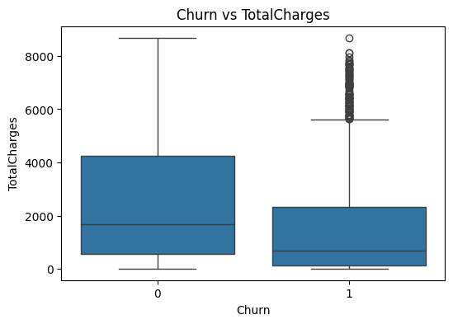
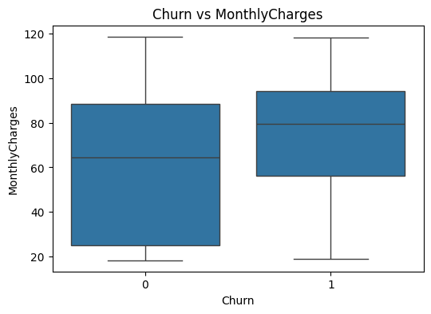
Fig 23: Telecom Customer Segmentation
Fig 21: Churn Vs Monthly Charges
Fig 22: Churn VS Total Charges

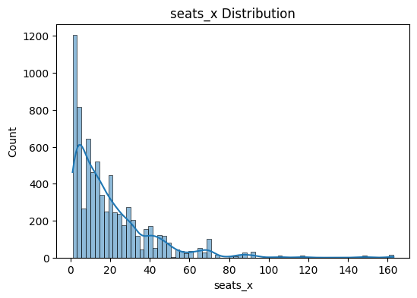
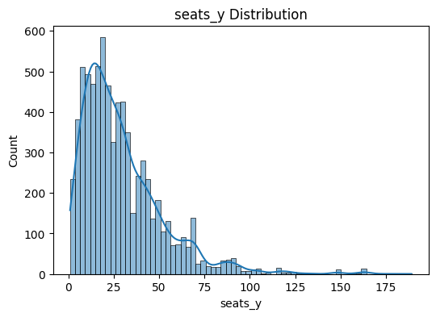
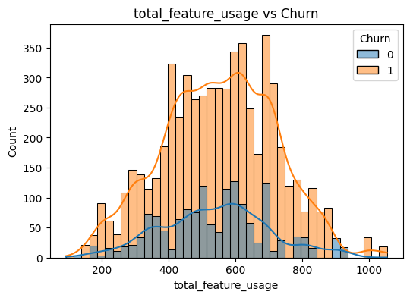
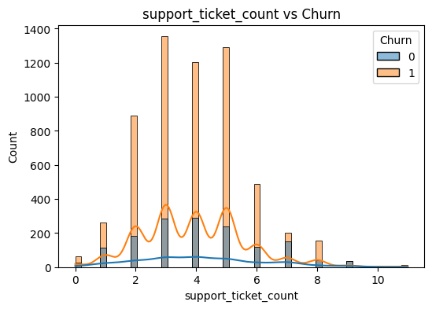
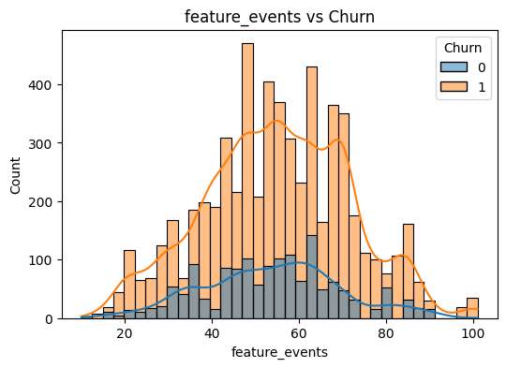
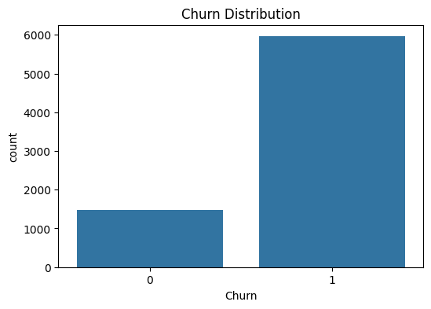
SaaS Industry
Fig 27: Support Ticket Count Vs Churn
Fig 25: Feature Events Vs Churn
Fig 29: Seats Y Distribution
Fig 28: Seat X Distribution 1
Fig 26 Total Feature Usage Vs Churn
Fig 24 : Churn Distribution
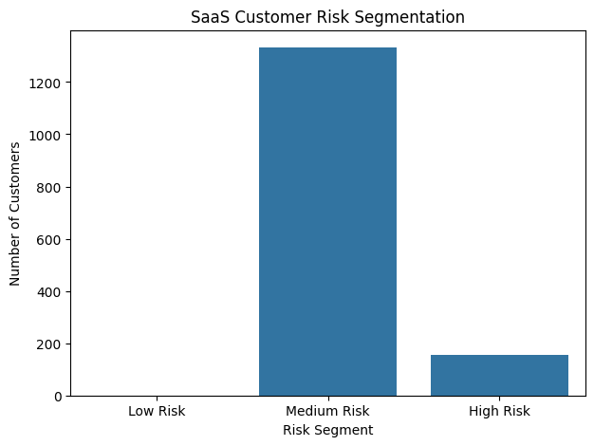
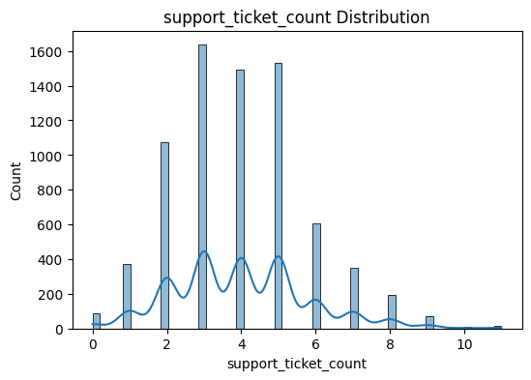
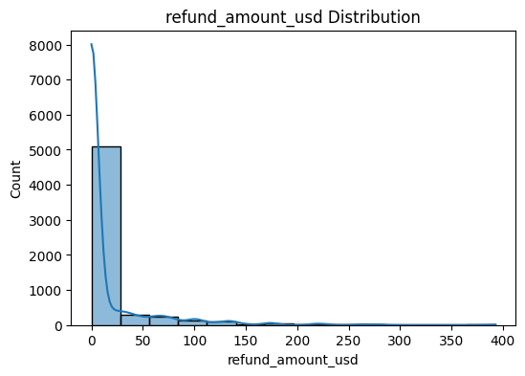
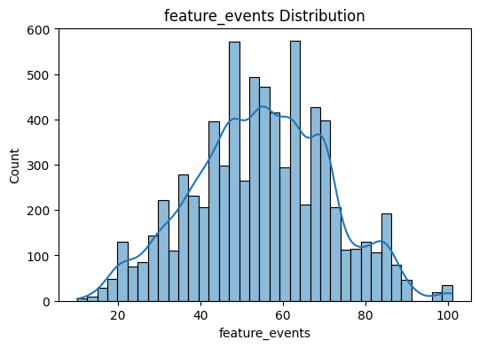
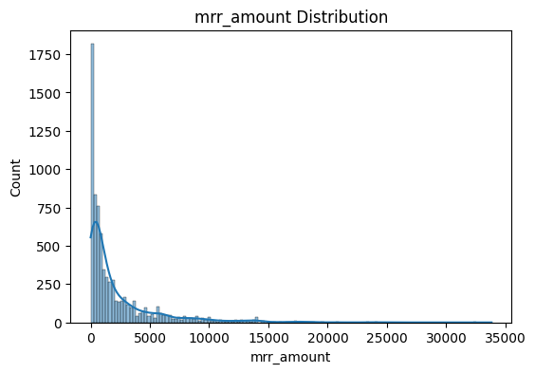
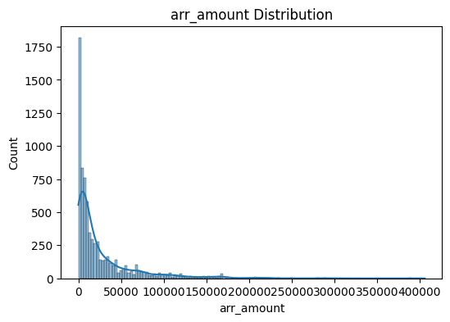
Fig 35: SaaS Customer Risk Segmentation
Fig 34: Support Ticket Distribution
Fig 32: Refund Amount Distribution
Fig 33: Feature Events Distribution
Fig 30: Mrr Amount Distribution
Fig 31: Arr Amount Distribution

Appendix C : Data Dictionary

Demographic Variables | Age, gender, industry, and location
Account Variables | Tenure, plan type, contract type
Béhavioral Variables | Transaction, service usage, feature activity
Financial Variables | Charges, revenue, credit limits
Target Variables | Churn (1= Churned, 0= Not Churned )
(Shrestha, Data Acquistion & Preparation Report , 2026)
- Telecom_data_dictonary.csv
- Saas_data_dictonary.csv
- Creditcard_data_dictonary.csv

